CHAPTER 4 – AC Machinery Fundamentals

Summary:

1. A simple loop in a uniform magnetic field
- The voltage induced in a simple rotating loop
- The Torque induced in a current-carrying loop

2. The Rotating Magnetic Field
- Proof of the rotating magnetic field concept
- The relationship between Electrical Frequency and the Speed of Magnetic field rotation
- Reversing the direction of magnetic field rotation

3. Magnetomotive Force and Flux Distribution on AC Machines

4. Induced Voltage in AC Machines
- The induced voltage in a coil on a two-pole stator
- The induced voltage in a three-phase set of coils
- The RMS voltage in a Three-Phase Stator

5. Induced Torque in an AC Machines

Synchronous Machines
Induction Machines
Magnetic field current is supplied by a separate dc power source

Field current is supplied by magnetic induction (transformer action) into their field windings.
The field circuits are located on their rotors.
AC Machines

1. A simple loop in a uniform magnetic field

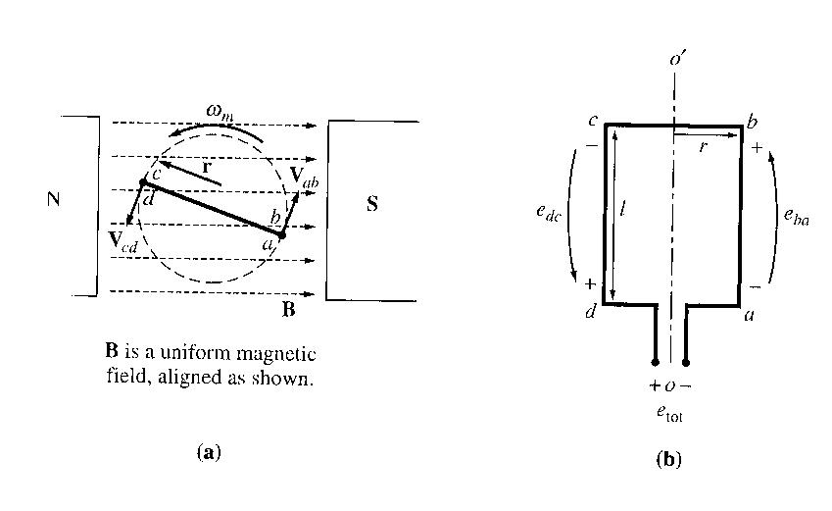
The figure below shows a simple rotating loop in a uniform magnetic field. (a) is the front view and (b) is the view of the coil. The rotating part is called the rotor, and the stationary part is called the stator.

This case in not representative of real ac machines (flux in real ac machines is not constant in either magnitude or direction). However, the factors that control the voltage and torque on the loop are the same as the factors that control the voltage and torque in real ac machines.

The voltage induced in a simple rotating loop

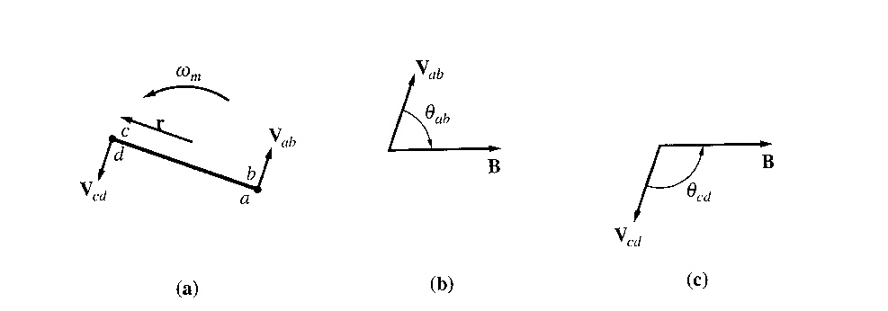
If the rotor (loop) is rotated, a voltage will be induced in the wire loop. To determine the magnitude and shape, examine the phasors below:

To determine the total voltage induced e_{tot} on the loop, examine each segment of the loop separately and sum all the resulting voltages. The voltage on each segment is given by equation

e_{ind} = (v x B) . l

(remember that these ideas all revert back to the linear DC machine concepts in Chapter 1).

1. Segment ab

The velocity of the wire is tangential to the path of rotation, while the magnetic field B points to the right. The quantity v x B points into the page, which is the same direction as segment ab. Thus, the induced voltage on this segment is:

e_{ba} = (v x B) . l
= vBl sin θ_{ab} into the page

2. Segment bc
In the first half of this segment, the quantity v x B points into the page, and in the second half of this segment, the quantity v x B points out of the page. Since the length l is in the plane of the page, v x B is perpendicular to l for both portions of the segment. Thus,
e_{cb} = 0

3. Segment cd
The velocity of the wire is tangential to the path of rotation, while B points to the right. The quantity v x B points into the page, which is the same direction as segment cd. Thus,

e_{cd} = (v x B) . l
= vBl sin θ_{cd} out of the page

4. Segment da
same as segment bc, v x B is perpendicular to l. Thus,
e_{da} = 0

Total induced voltage on the loop e_{ind} = e_{ba} + e_{cb} + e_{dc} + e_{ad}
= vBl sin θ_{ab} + vBl sin θ_{cd}
= 2 vBL sinθ

since θ_{ab} = 180º - θ_{cd} and sin θ = sin (180º - θ )

Alternative way to express e_{ind}:

If the loop is rotating at a constant angular velocity ω, then the angle θ of the loop will increase linearly with time.
θ = ωt

also, the tangential velocity v of the edges of the loop is:

v= r ω

where r is the radius from axis of rotation out to the edge of the loop and ω is the angular velocity of the loop. Hence,
e_{ind} = 2r ωBl sin ωt
since area, A = 2rl,

e_{ind} = ABω sin ωt

Finally, since maximum flux through the loop occurs when the loop is perpendicular to the magnetic flux density lines, so
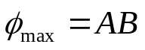

Thus,
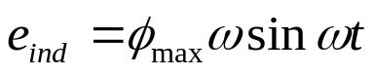

From here we may conclude that the induced voltage is dependent upon:
- Flux level (the B component)
- Speed of Rotation (the v component)
- Machine Constants (the l component and machine materials)

The Torque Induced in a Current-Carrying Loop

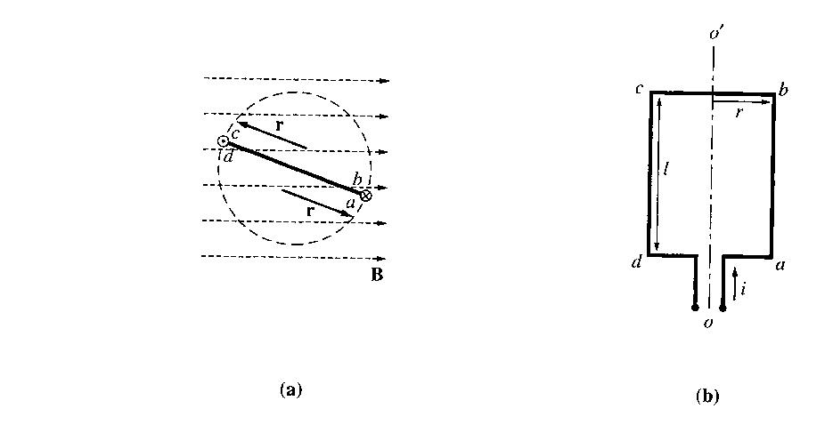
Assume that the rotor loop is at some arbitrary angle θ wrt the magnetic field, and that current is flowing in the loop.

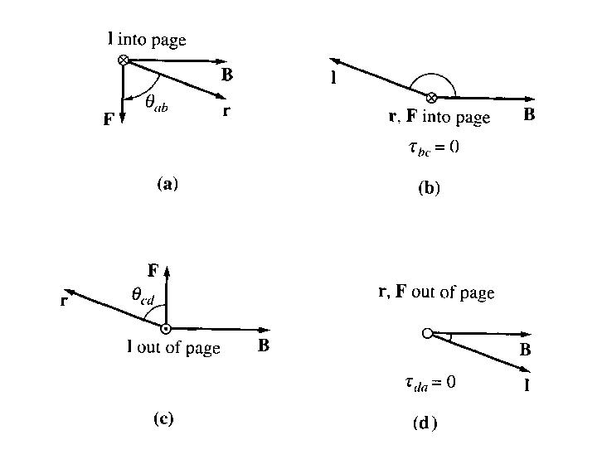
To determine the magnitude and direction of the torque, examine the phasors below:

The force on each segment of the loop is given by:
F = i (l x B )
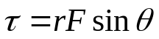

Torque on that segment,

1. Segment ab
The direction of the current is into the page, while the magnetic field B points to the right. (l x B) points down. Thus,
F = i (l x B )
= ilB down

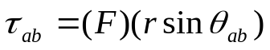Resulting torque,
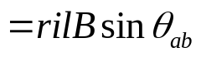
clockwise

2. Segment bc
The direction of the current is in the plane of the page, while the magnetic field B points to the right. (l x B) points into the page. Thus,
F = i (l x B )
= ilB into the page

Resulting torque is zero, since vector r and l are parallel and the angle θ_{bc} is 0.
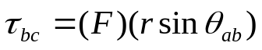

= 0

3. Segment cd
The direction of the current is out of the page, while the magnetic field B points to the right. (l x B) points up. Thus,
F = i (l x B )
= ilB up
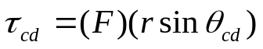
Resulting torque,
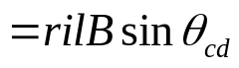
clockwise

4. Segment da
The direction of the current is in the plane of the page, while the magnetic field B points to the right. (l x B) points out of the page. Thus,
F = i (l x B )
= ilB out of the page

Resulting torque is zero, since vector r and l are parallel and the angle θ_{da} is 0.
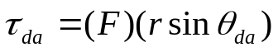

= 0

The total induced torque on the loop:
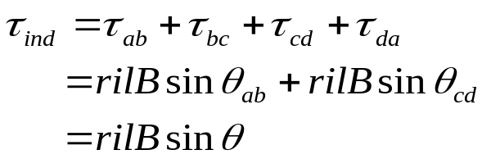

Note : the torque is maximum when the plane of the loop is parallel to the magnetic field, and the torque is zero when the plane of the loop is perpendicular to the magnetic field.

An alternative way to express the torque equation can be done which clearly relates the behaviour of the single loop to the behaviour of larger ac machines. Examine the phasors below:

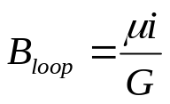If the current in the loop is as shown, that current will generate a magnetic flux density B_{loop} with the direction shown. The magnitude of B_{loop} is:

Where G is a factor that depends on the geometry of the loop.

The area of the loop A is 2rl and substituting these two equations into the torque equation earlier yields:
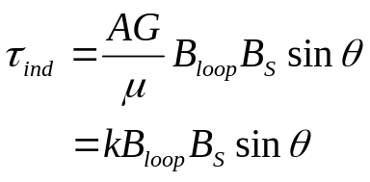

Where k=AG/µ is a factor depending on the construction of the machine, B_{S} is used for the stator magnetic field to distinguish it from the magnetic field generated by the rotor, and θ is the angle between B_{loop} and B_{S}.
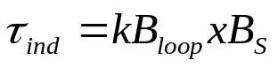
Thus,

From here, we may conclude that torque is dependent upon:

- Strength of rotor magnetic field
- Strength of stator magnetic field
- Angle between the 2 fields
- Machine constants

2. The Rotating Magnetic Field

Before we have looked at how if two magnetic fields are present in a machine, then a torque will be created which will tend to line up the two magnetic fields. If one magnetic field is produced by the stator of an ac machine and the other by the rotor, then a torque will be induced in the rotor which will cause the rotor to turn and align itself with the stator magnetic field.

If there were some way to make the stator magnetic field rotate, then the induced torque in the rotor would cause it to ‘chase’ the stator magnetic field.

How do we make the stator magnetic field to rotate?

Fundamental principle – a 3-phase set of currents, each of equal magnitude and differing in phase by 120º, flows in a 3-phase winding, then it will produce a rotating magnetic field of constant magnitude.
The rotating magnetic field concept is illustrated below – empty stator containing 3 coils 120º apart. It is a 2-pole winding (one north and one south).

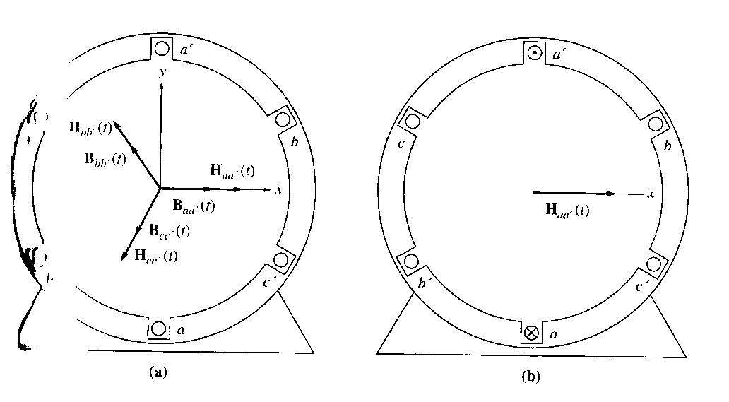

(a) A simple three phase stator. Currents in this stator are assumed positive if they flow into the unprimed end and out the primed end of the coils. The H produced by each coil are also shown.
(b) The magnetizing intensity vector H_{aa’} (t) produced by a current flowing in coil aa’.

Let’s apply a set of currents to the stator above and see what happens at specific instants of time. Assume currents in the 3 coils are:
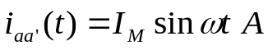

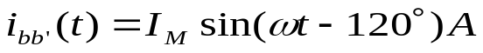

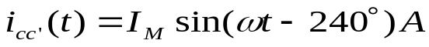

The current in coil aa’ flows into the a end of the coil and out the a’ end of the coil. It produces the magnetic field intensity:

The flux densities equations are:

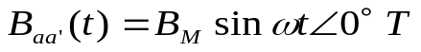

Where B_{M} = µ H_{M}.

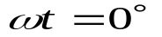At time
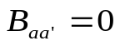

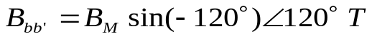
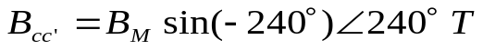

The total magnetic field from all three coils added together will be

B_{net} = B_{aa’} + B_{bb’} +B_{cc’}
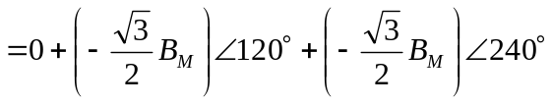

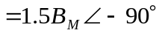

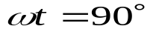At time
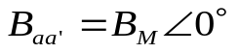

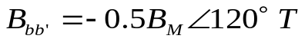

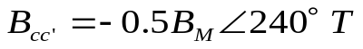

The total magnetic field from all three coils added together will be

B_{net} = B_{aa’} + B_{bb’} +B_{cc’}

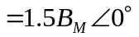

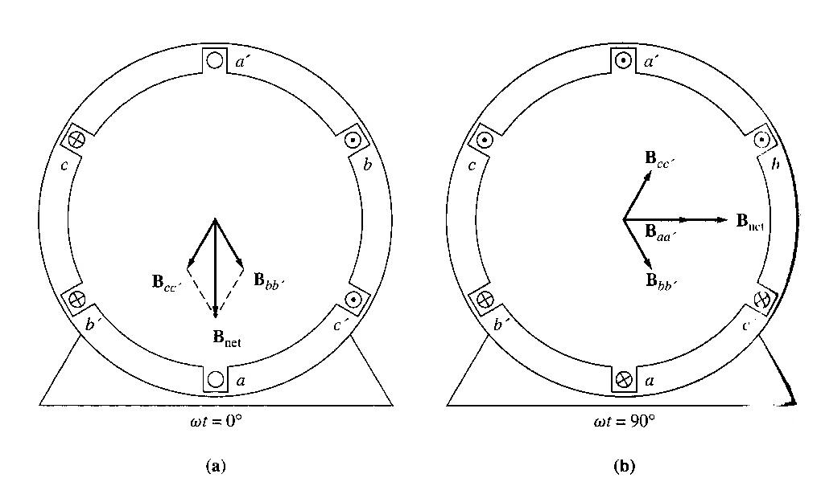
The resulting magnetic flux is as shown below:

Proof of Rotating Magnetic Field Concept

At any time t, the magnetic field will have the same magnitude 1.5 B_{M} and it will continue to rotate at angular velocity ω.

Proof:
Refer again to the stator in Figure 4.1. x direction is to the right and y direction is upward.
Assume that we represent the direction of the magnetic field densities in the form of:
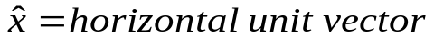
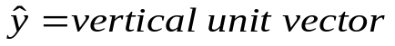

To find the total magnetic flux density in the stator, simply add vectorially the three component magnetic fields and determine their sum.

We know that:

We may convert the total flux density into unit vector forms to give:

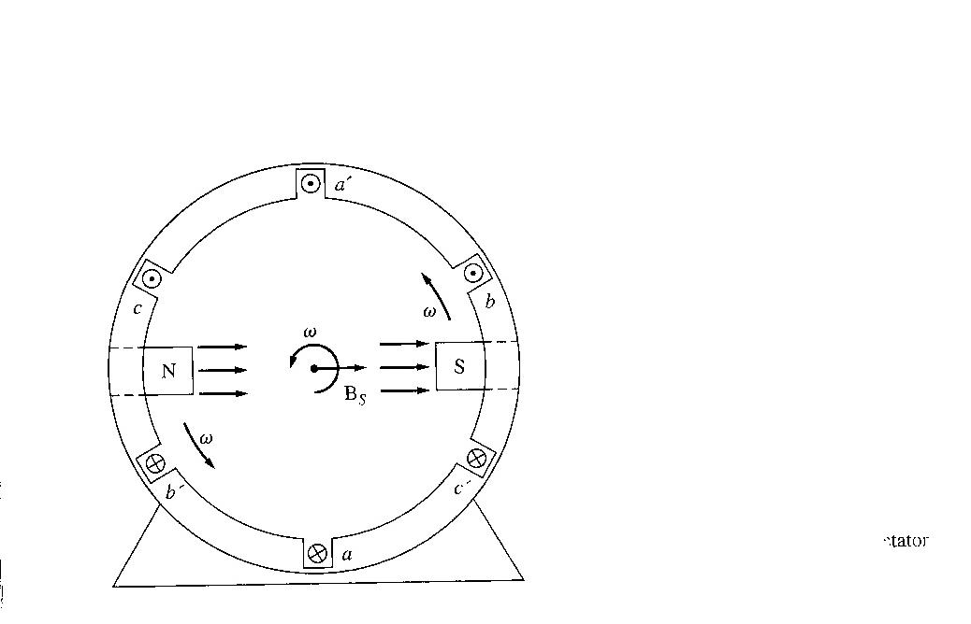
Notice that the magnitude of the field is a constant 1.5B_{M} and the angle changes continually in a counterclockwise direction at angular velocity ω. Αlso, at ωt=0°, B_{net}=1.5B_{M} -90°, and at ωt=90°, B_{net}=1.5B_{M} 0°.

The Relationship between Electrical Frequency and the Speed of Magnetic Field Rotation

The figure above shows that the rotating magnetic field in this stator can be represented as a north pole (the flux leaves the stator) and a south pole ( flux enters the stator).

These magnetic poles complete one mechanical rotation around the stator surface for each electrical cycle of the applied current. The mechanical speed of rotation of the magnetic field in revolutions per second is equal to electric frequency in hertz:

f_{e} (hertz) = f_{m} (revolutions per second) two poles
ω_{e} (radians per second) = ω_{m} (radians per second) two poles

The windings on the 2-pole stator above occur in the order a – c’ – b – a’ – c – b’

If we were to double the amount of windings, hence the sequence of windings will be as follows:
a1 – c1’ – b1 – a1’ – c1 – b1’ – a2 – c2’ – b2 – a2’ – c2 – b2’
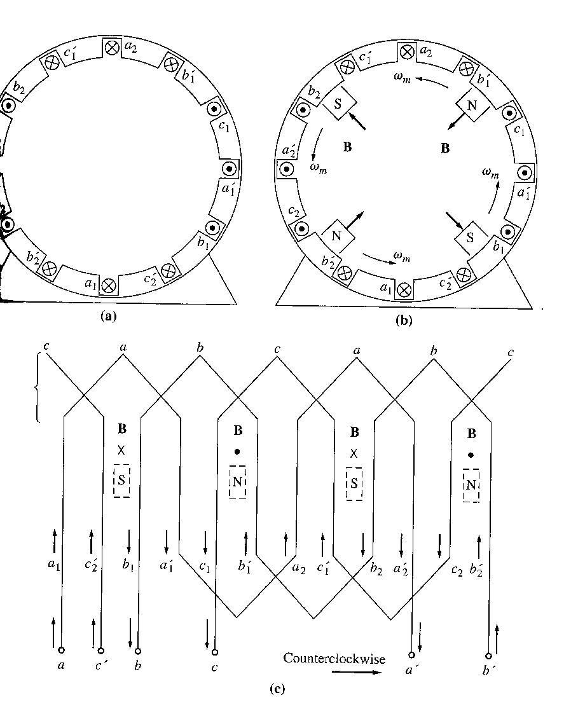
For a three-phase set of currents, this stator will have 2 north poles and 2 south poles produced in the stator winding, (refer figure (b) below):

(a) A simple four-pole stator winding. (b) The resulting stator magnetic poles. Notice that there are moving poles of alternating polarity every 90° around the stator surface. (c) a winding diagram of the stator as seen from its inner surface, showing how the stator currents produce north and south magnetic poles.

In this winding, a pole moves only halfway around the stator surface in one electrical cycle. Since one electrical cycle is 360 electrical degrees, and mechanical motion is 180 mechanical degrees, the relationship between the electrical angle θ_{e} and the mechanical θ_{m} in this stator is

θ_{e} = 2 θ_{m}

Thus, for a four pole winding, the electrical frequency of the current is twice the mechanical frequency of rotation:

f_{e} = 2 f_{m}
ω_{e} = 2 ω_{m}

Therefore the general format will be as follows:
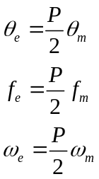
Also,
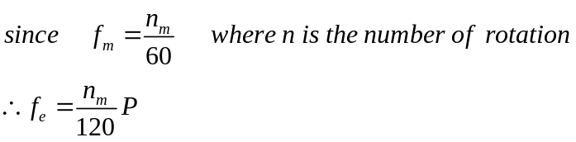

Reversing the direction of Magnetic Field Rotation

If the current in any two of the 3 coils is swapped, the direction of the magnetic field’s rotation will be reversed.

To prove this, phases B and C are switched:

B_{net} = B_{aa’} + B_{bb’} +B_{cc’}

Converting it into x and y unit vectors will give:

Note the +ve sign, which shows the change of magnetic field rotation.

3. Magnetomotive Force and Flux Distribution on AC Machines

Assumptions:
- Flux produced inside an ac machine is in free space
- Direction of flux density produced by a coil of wire is perpendicular to the plane of the coil
- Direction of flux given by the right hand rule.

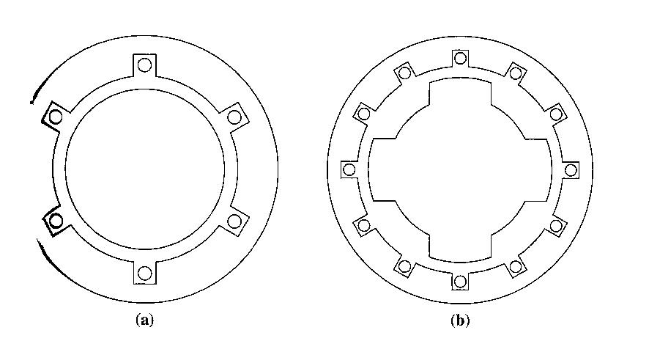
However, the flux in a real machine does not follow these assumptions, since there is a ferromagnetic rotor in the centre of the machine with a small air gap between the rotor and the stator. The rotor can be cylindrical (a) (nonsalient-pole), or it can have pole faces projecting out from its surface (b) (salient pole).

In this course, the discussion will be restricted to machines with cylindrical rotors.

The reluctance of the air gap in this machine is much higher than the reluctances of either the rotor or the stator, so the flux density vector B takes the shortest possible path across the air gap and jumps perpendicularly between the rotor and the stator.

To produce a sinusoidal voltage in a machine like this, the magnitude of the flux density vector B must vary in a sinusoidal manner along the surface of the air gap. The flux density will vary sinusoidally only if the magnetizing intensity H (and mmf) varies in a sinusoidal manner along the surface of the air gap.
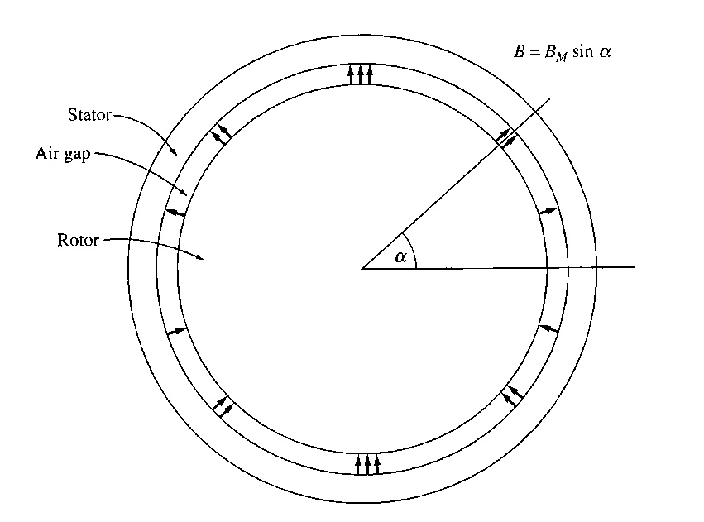

A cylindrical rotor with sinusoidally varying air-gap flux density

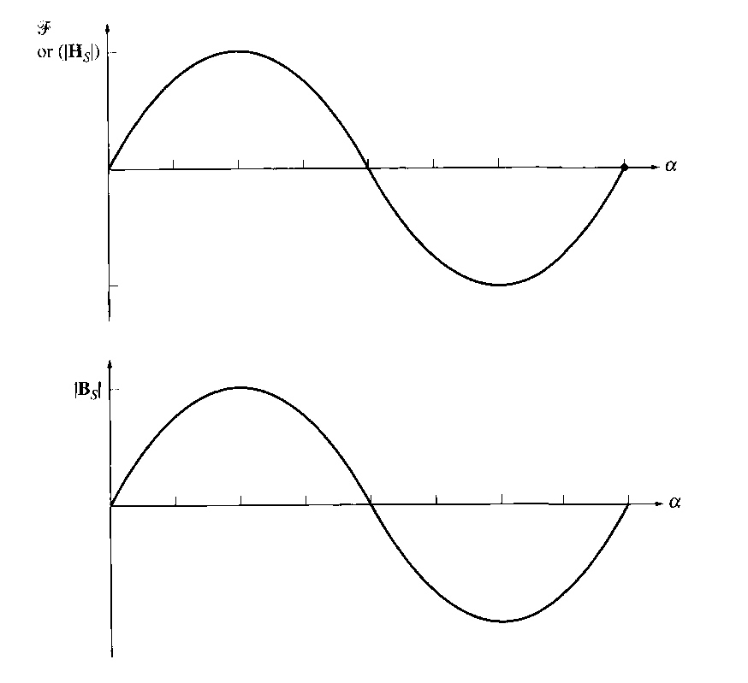

The mmf or H or B as a function of angle in the air gap

To achieve a sinusoidal variation of mmf along the surface of the air gap is to distribute the turns of the winding that produces the mmf in closely spaced slots around the surface of the machine and to vary the number of conductors in each slots in a sinusoidal manner.

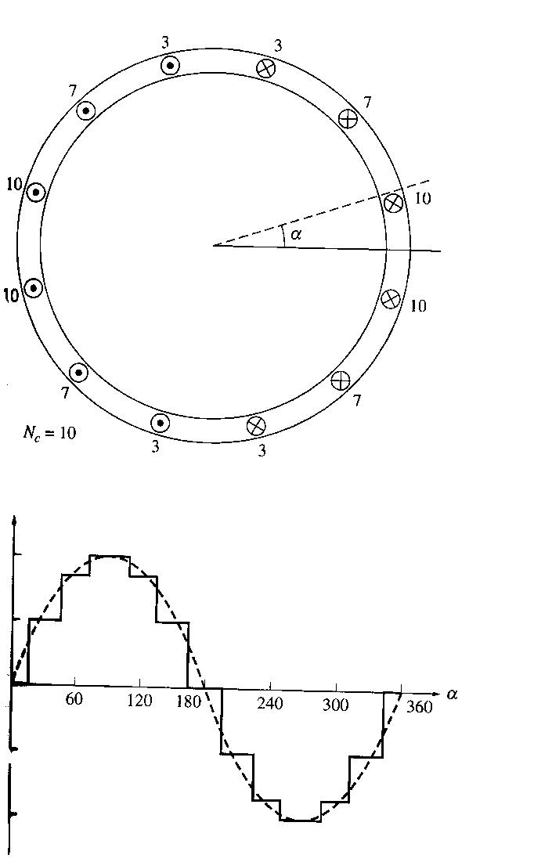

An ac machine with a distributed stator winding designed to produce a sinusoidally varying air gap flux density. The number of conductors in each slot is indicated in the diagram.

The mmf distribution resulting from the winding, compared to an ideal transformer.

The number of conductors in each slot is n_{C} = N_{C} cos α where N_{C} is the number of conductors at an angle of 0 degree. The distribution of conductors produces a close approximation to a sinusoidal distribution of mmf. The more slots there are and the more closely spaced the slots are, the better this approximation becomes.

In practice, it is not possible to distribute windings exactly as in the n_{C} equation above, since there are only a finite number of slots in a real machine and since only integral numbers of conductors can be included in each slot.

4. Induced Voltage in AC Machines

The induced voltage in a Coil on a Two-Pole Stator

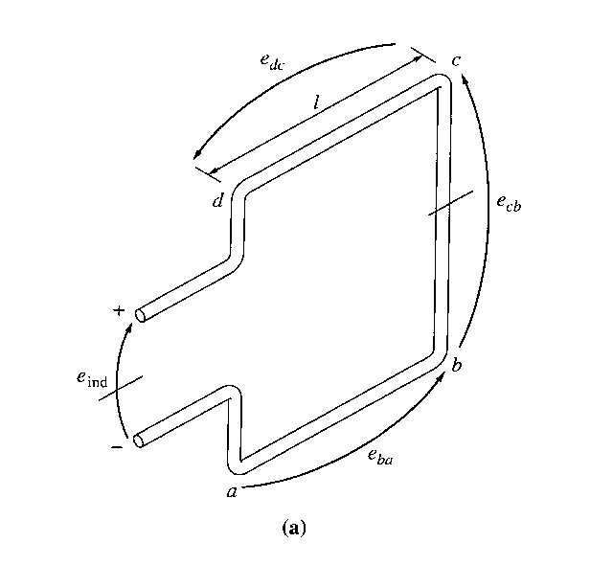
Previously, discussions were made related to induced 3 phase currents producing a rotating magnetic field. Now, lets look into the fact that a rotating magnetic field may produce voltages in the stator. The Figures below show a rotating rotor with a sinusoidally distributed magnetic field in the centre of a stationary coil.

A rotating rotor magnetic field inside a stationary stator coil

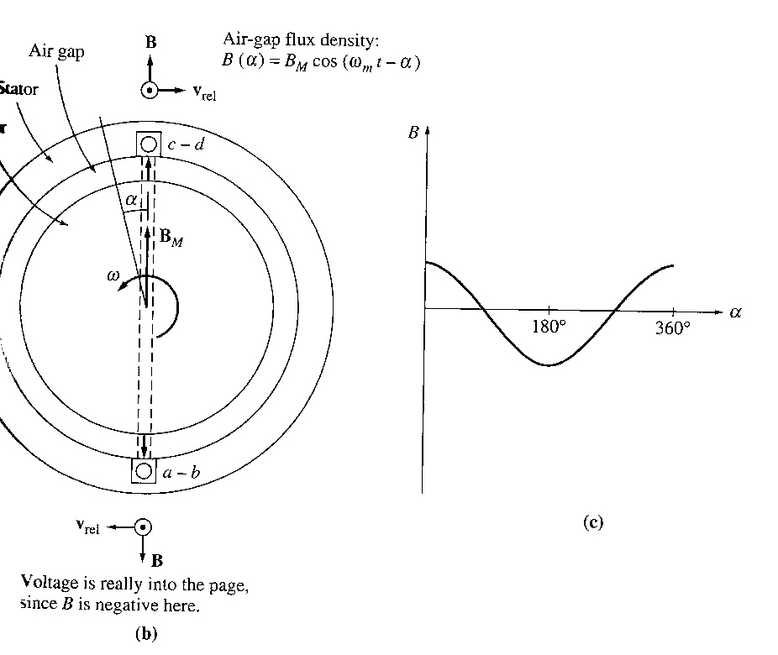

The vector magnetic flux densities and velocities on the sides of the coil.
The flux density distribution in the air gap.

Assume that the magnetic of the flux density vector B in the air gap between the rotor and the stator varies sinusoidally with mechanical angle, while the direction of B is always radially outward. The magnitude of the flux density vector B at a point around the rotor is given by:

B = B_{M} cos α

Note that α is the angle between the maximum flux density (B_{m}) and the current magnetic flux density phasor B. Since the rotor is itself rotating within the stator at an angular velocity ω_{m} the magnitude of the flux density vector B at any angle α around the stator is given by:

B = B_{M} cos (ωt - α)

Induced voltage in a wire is e = (v x B) l

However, this equation was derived for the case of a moving wire in a stationary magnetic field. In this case, the wire is stationary and the magnetic field is moving, so the equation for induced voltage does not directly apply. Hence, we need to assume that we are “sitting on the magnetic field” so that the magnetic field appears to be stationary, and the sides of the coil will appear to go by at an apparent velocity v_{rel} and the equation can be applied.

The total voltage induced in the coil will be the sum of the voltages induced in each of its four sides. These are determined as follows:

1. Segment ab
α = 180º. Assume that B is directed radially outward from the rotor, the angle between v and B in segment ab is 90º, while v x B is in the direction of l, so
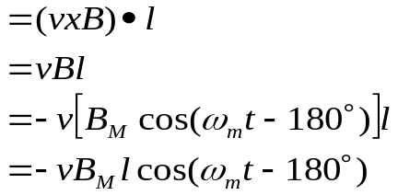 e_{ba}
Directed out of the page

Where the minus sign comes from the fact that the voltage is built up with a polarity opposite to the assumed polarity.

2. Segment bc
The voltage is zero, since the vector quantity v x B is perpendicular to l.

3. Segment cd
α = 0º
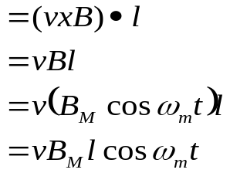Assume that B is directed radially outward from the rotor, the angle between v and B in segment cd is 90º, while v x B is in the direction of l, so
e_{ba}
Directed out of the page

4. Segment da
The voltage is zero, since the vector quantity v x B is perpendicular to l.

Therefore total induced voltage:

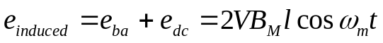
Since, 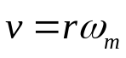

Therefore,
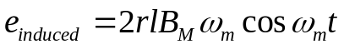

Since, 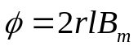
And the angular mechanical velocity should be equal to the angular electrical velocity,

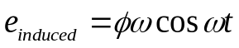

or (taking into account number of turns of windings),

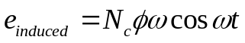

Remember: This derivation goes through the induced voltage in the stator when there is a rotating magnetic field produced by the rotor.

The Induced Voltage in a 3-Phase Set of Coils

If the stator now has 3 sets of different windings as such that the stator voltage induced due to the rotating magnetic field produced by the rotor will have a phase difference of 120º, the induced voltages at each phase will be as follows:

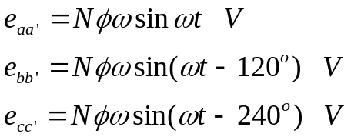

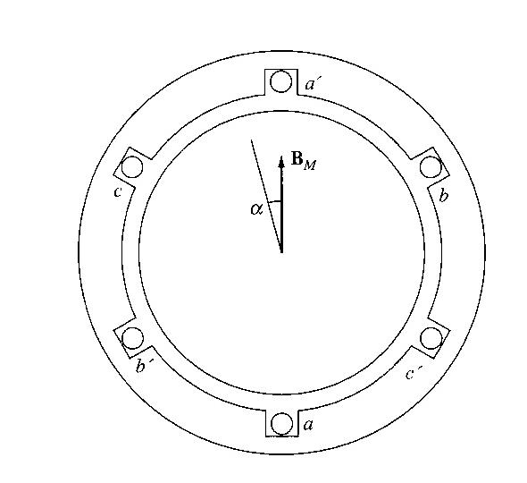

The production of three-phase voltages from three coils spaced 120º apart

Therefore, a 3 phase set of currents flowing into the stator windings and hence generating a rotating magnetic field (earlier case), and at the same time, a rotating magnetic field produced by the rotor will be able to generate 3 phase voltages in a stator.

Referring to the induced voltage derived earlier, the maximum induced voltage is when sin has a value of 1, hence,
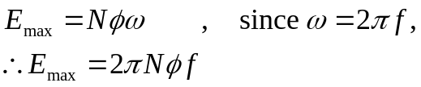

Therefore, the rms voltage at the 3 phase stator:
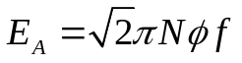

Note: These are induced voltages at each phase, as for the line-line voltage values; it will depend upon how the stator windings are connected, whether as Y or Δ.

5. Induced Torque in an AC Machines

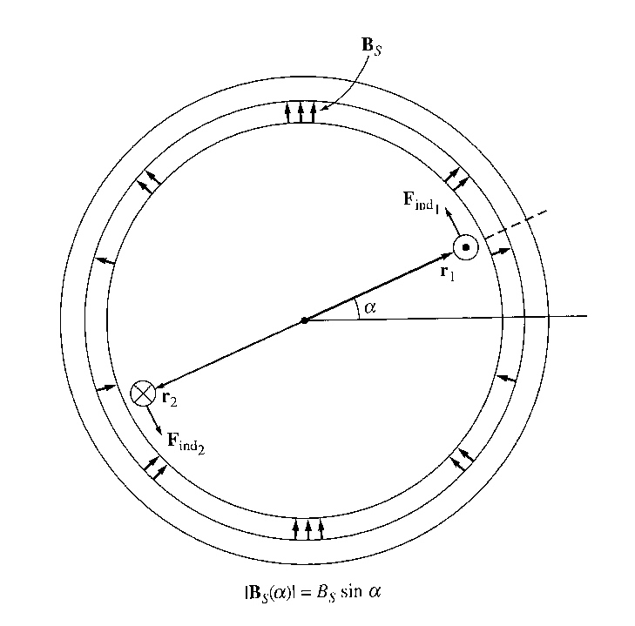
In ac machines under normal operating conditions, there are 2 magnetic fields present - a magnetic field from the rotor circuit and another magnetic field from the stator circuit. The interaction of these two magnetic fields produces the torque in the machine, just as 2 permanent magnets near each other will experience a torque, which causes them to line up.

A simplified ac machine with a sinusoidal stator flux distribution and a single coil of wire mounted in the rotor.

There will also be current flowing through the rotor windings (this will create another magnetic field originating from the wire), which will create force that can be found using the right hand rule. Its resultant direction may be found in the diagram above.

The stator flux density distribution in this machine is
B_{S}(α)=B_{S} sin α

Where B_{S} is the magnitude of the peak flux density; B_{S} (α) is positive when the flux density vector points radially outward from the rotor surface to the stator surface.

How much torque is produced in the rotor of this simplified ac machine? This is done by analyzing the force and torque on each of the two conductors separately:

The induced force on conductor l is
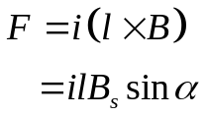
Hence torque at conductor 1:
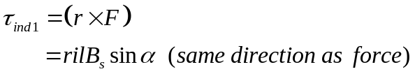

The same may be found for conductor 2, hence the total torque induced:

The current i flowing in the rotor coil produces a magnetic field of its own. The direction of the peak of this magnetic field is given by the right hand rule, and the magnitude of its magnetizing intensity H_{R} is directly proportional to the current flowing in the rotor, and H_{R} = Ci where C is a constant of proportionality.

The angle between the peak of the stator flux density B_{S} and the peak of the rotor magnetizing intensity H_{R} is γ. Futhermore,
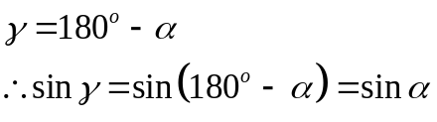

Therefore the torque equation may be represented in the following form:
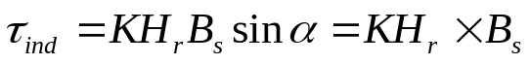
Note that K is a constant value.
Since B_{R}= μH_{R},
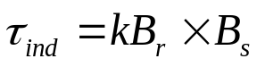
The constant k is a value which will be dependent upon the permeability of the machine’s material. Since the total magnetic field density will be the summation of the B_{S} and B_{R}, hence:
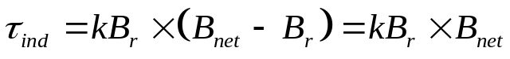

If there is an angle δ between B_{net} and B_{R},
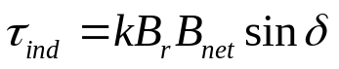

These 3 equations will be used to help develop a qualitative understanding of the torque in ac machines.

